

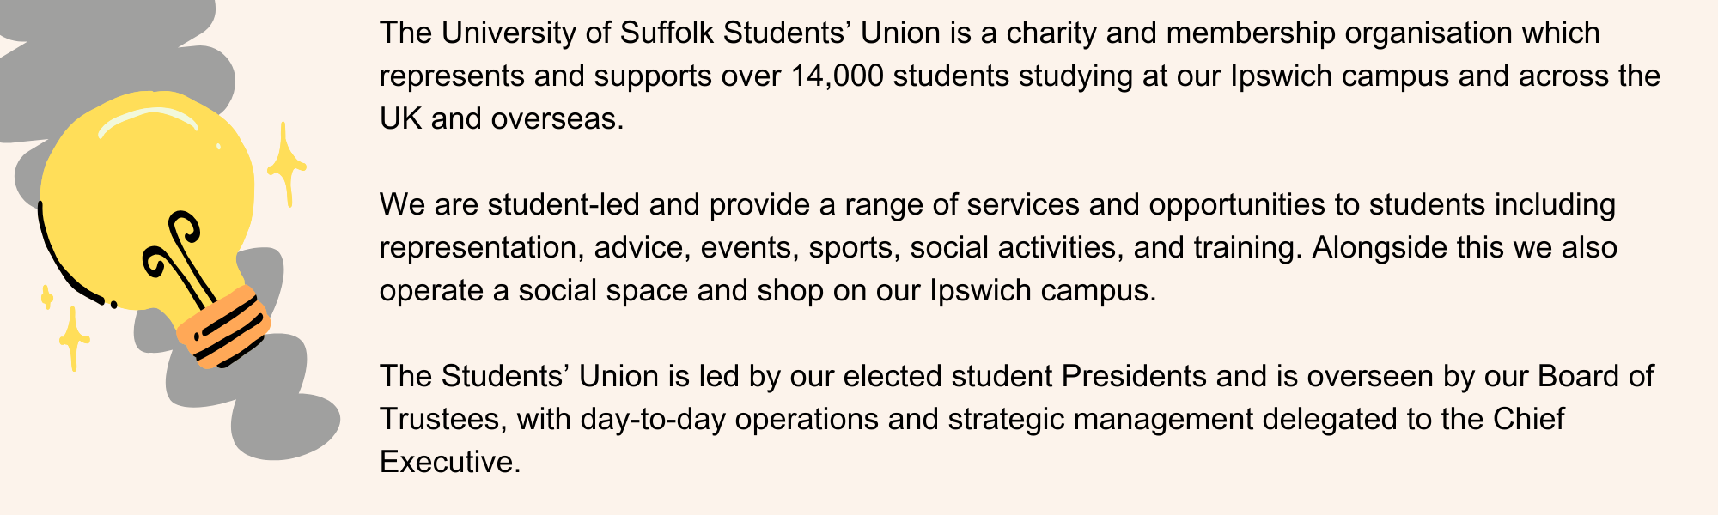About University of Suffolk Students’ Union

Some Important stuff

|  |  |  |  |  |
| --- | --- | --- | --- | --- |
| **Location**  University of Suffolk Students’ Union, Library Building | **Salary**  £11.44 per hour + holiday pay | **Hours**  Varied and flexible around studies | **Reports to**  Head of Operations |  |
| bf55dddf393f4eb4b4963726b0f41a46.jpg | 056dbcdf9c0d9a9a4c2376adc45396c2.jpg | 26a96290334f864d7d8b81982b9fd4fa.jpg | a2c83e3f8fac39a3193822d030a9dd8b.jpg | bb8190c6403382a67d786d4512419153.jpg |

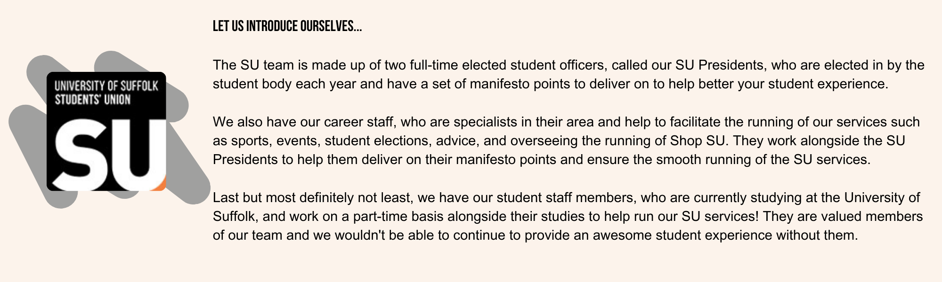

Front of house assistant

|  |  |
| --- | --- |
| person specification |  |
| criteria |  |
| **Knowledge & Experience** |  |
| Experience of customer services | Desirable |
| Knowledge of the role of the Students’ Union and the work that it undertakes at the University of Suffolk | Desirable |
| Current student at the University of Suffolk | Essential |
| **Skills** |  |
| Exceptional interpersonal and communication skills (written and oral) | Essential |
| Appropriate levels of IT skills | Essential |
| Self-motivated and able to work independently as well as part of a team | Essential |
| **Values and Ethics** |  |
| Desire to work within a democratic student-led environment | Essential |
| Commitment to equal opportunities | Essential |
| High standards of personal integrity | Essential |

General Duties

* Ensure ShopSU is stocked and kept tidy throughout the day.
* Support students and other users when using the self-service tills.
* Monitor the SU inbox and take appropriate action.
* Act as an ambassador for the Students’ Union and provide assistance to anyone that comes to the Front Desk.
* Comply with the Union’s governance and policies.
* Undertake training and development related to the role.

Hours and Other Information:

* ShopSU is open from 8:30 to 16:00 Monday to Friday.
* Working hours are variable and flexible around studies.

Disclaimer

This job description outlines the major duties associated with the post. It is not exhaustive, and other duties of a similar level may be required. The duties may alter due to changes in legislation, policy, or operating decisions, with training provided as necessary.

Contact

For further information, or to apply for this role, please submit your CV and application form to su.hr@uos.ac.uk

**Website:** <https://www.uosunion.org>